

Cross Platform Mobile SDK
For

Verizon Data Orchestration

Document Version: 1.0

Date: [30/12/2022]

Contents

1. Contents 2
2. Version Details 2
Overview 4
3. Introduction To ASN.1 4
3.1 Types of messages 5
4. Build Environment Requirements 6
5. Cross mobile SDK/IOSApp: Setup 7
5.1 High Level Architecture 8
5.2 React Native Flow 8
5.3 IOS App Flow 9
5.4 Libraries Used 9
5.5 Main APIs/ Interfaces 9

Version Details

Please document all changes made to this document since initial distribution.

Versions | Amendments
1.2.08122022 | 1. User Login Page  2. Home Page with Publisher & Subscriber Navigation  3. Publisher screen with User Mode Carousel  Pedestrian: User can publish the PSM (Personnel Safety Message) details  General Vehicle: User can publish BSM (Basic Safety Message) details  Emergency Vehicle: User can publish EVA (Emergency Vehicle Alert) & RSA (Road Side Alert).  4. Subscribe Screen will display the data being subscribed from Verizon vRSU Server. Subscriber screen has the below functions;  Live Feed: Four Tab that differentiates and display the types of Data user receives.  GLOSA: Displays the Advisory Speed so as the immediate Traffic signal in approach is Green while crossing.  Signal Phase: Displays the Signal State of the upcoming Traffic Intersection
1.0.0 | 1. Introduced separate functional screen for subscribing  GLOSA Screen  2. Signal & Lane Advisory Screen  3. Fully Screen Live Feed Display with GLOSA & Signal Screen Navigation Button  4. JER Publishing and Subscribing  5. In Spat screen-- showing next intersection and signal status of connected lanes(including direction) according to current lane on which Vehicle is moving.

Overview
This document describes all the technical aspects of the data orchestration application.
The main motive of the application is to facilitates user to get the fined information about the lane or street in which they are travelling.

Cross development mobile SDK/IOS App is establishing direct connection with MQTT to publish and subscribe the data.
App uses ASN.1 (Abstract Syntax Notation One) encoding rules to publish the data to MQTT.
UPER & JER are the 2 encoded formats used by app.
For more details on ASN

Introduction To ASN.1
- Abstract Syntax Notation One (ASN.1) is a standard interface description language for defining data structures that can be serialized and deserialized in a cross-platform way.
- It is broadly used in telecommunications and computer networking, and especially in cryptography.
- Protocol developers define data structures in ASN.1 modules, which are generally a section of a broader standards document written in the ASN.1 language.
- ASN.1 is both human-readable and machine-readable, an ASN.1 compiler can compile modules into libraries of code, codecs, that decode or encode the data structures.
In the application we are using 2 encoding rules.
- UPER (Unaligned Packed Encoding Rules)
- JER (JSON Encoding Rules)

UPER: This Unaligned Packed Encoding are the most compact encoding rules. The goal of PER is to create smaller encodings. An advantage of using PER is the way it encodes data by examining constraints. PER does not send the Tag of the TLV since the order in which components of the message occur is known. PER also does not send the Length of the TLV if the Value has a fixed length. PER also uses additional information from the ASN.1 message description to eliminate redundant information from the Value portion of the TLV, thus making PER messages quite compact and suitable for environments in which bandwidth conservation is important.
For creation of UPER data, first we need to create a schema. Let us say my schema is,
BEGIN
FooBar ::= SEQUENCE {
Foo INTEGER (-512..511),
Bar INTEGER (-512..511)
}
END

Now, in case we need to encode below data:
test FooBar ::=
{
Foo 10,
Bar -10
}

It will be encoded as:
HEX: 0x829F60
BIN: 100000101001111101100000

Although, in our application we are directly using the ASN.1 libraries APIs to encode or decode the data.

JER: This JSON encoding rules was designed to allow applications to represent any ASN.1 value in JavaScript Object Notation (JSON). For example, an application that receives BER- or PER-encoded messages conforming to a certain ASN.1 schema will be able to re-encode the messages in JSON. This capability can be used to exchange data with other applications that do not understand ASN.1 but know how to parse or write JSON.
Below is the example of JER data for MAP being published to MQTT.

Types of messages
- BSM: The basic safety message (BSM) is used in a variety of applications to exchange safety data regarding vehicle state. This message is broadcast frequently to surrounding vehicles with data content as required by safety and other applications. Transmission rates are beyond the scope of this standard, but a rate 10 times per second is typical when congestion control algorithms do not prescribe a reduced rate.

- PSM: The Personal Safety Message (PSM) is used to broadcast safety data regarding the kinematic state of various types of Vulnerable Road Users (VRU), such as pedestrians, cyclists, or road workers. Data items which are optional are included in a PSM as needed according to policies that are beyond the scope of this standard.

- EVA: The emergency vehicle alert message is used to broadcast warning messages to surrounding vehicles that an emergency vehicle (typically an incident responder of some type) is operating in the vicinity and that additional caution is required. The message itself is built on the original ATIS roadside alert message which in turn uses the common ITIS phrase list to both describe the event and provide advice and recommendation for travellers.
- SPaT: The signal phase and timing (SPAT) message is used to convey the current status of one or more signalized intersections. Along with the MSG_MapData message (which describes a full geometric layout of an intersection), the receiver of this message can determine the state of the signal phasing and when the next expected phase will occur. MAP: The MapData message is used to convey many types of geographic road information. At the current time, its primary use is to convey one or more intersection lane geometry maps within a single message. The map message content includes such items as complex intersection descriptions, road segment descriptions, high speed curve outlines (used in curve safety messages), and segments of roadway (used in some safety applications).

- MapData: message may convey descriptions of one or more geographic areas or intersections. The contents of this message involve defining the details of indexing systems that are in turn used by other messages to relate additional information (for example, the signal phase and timing via the SPAT message) to events at specific geographic locations on the roadway.

- RSA: This message is for alerting about roadway hazards; not for vehicle cooperative communications, mayday, or other safety applications. It is generally presumed that each receiving device is aware of its own position and heading; but, it is neither a requirement to receive and understand these messages, nor is having a local base map.

For above messages, we are using a unique identifier Key. Based on that key, we are using those messages in dashboard UI.
Sno | Type of message | Key
1 | BSM | BasicSafetyMessage
2 | PSM | PersonalSafetyMessage
3 | EVA | EmergencyVehicleAlert
4 | SPAT | SPAT
5 | MAP | MapData

Build Environment Requirements
- MAC book with minimum 16 GB RAM
- iPhone for development and testing
- Apple’s developer account
- XCode
- Visual studio
- Node should be installed

Cross mobile SDK/IOSApp: Setup

Step 1: Install Node.JS & Watchman on computer.

brew install node
brew install watchman
(Please verify Ruby is installed on the machine, if Yes Cocoapods will be present by default)

Step 2: Install Xcode.
Step 3: Install CLI tools for React Native
npm install -g react-native-cli @react-native-community/cli

Step 4: Building the Project:

- Go the Root Directory of the React Native Project.
npm install
- Go to pubsub-rn/iOS, Install Pod
pod install
- Go to Root Directory of the project.
- Start React Native Metro:
npx react-native start
- Run the Project
npx react-native run-ios

High Level Architecture
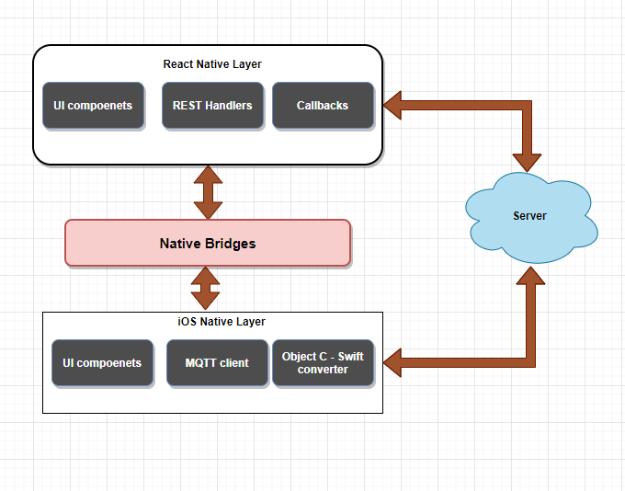

React Native Flow

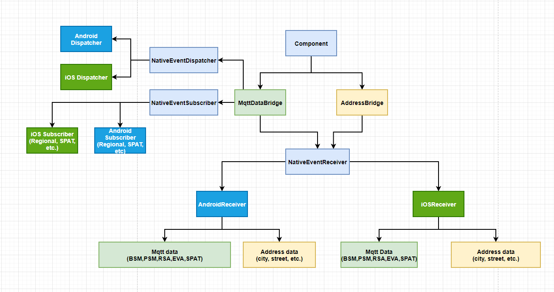

IOS App Flow
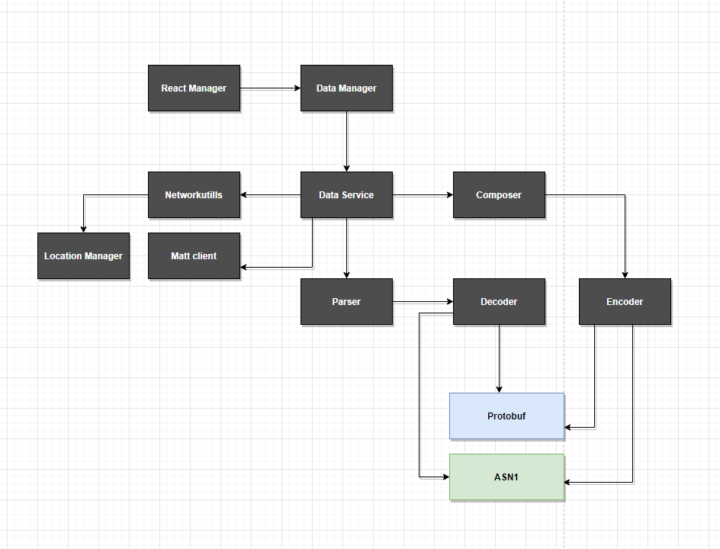

Swift to Objective C bridging
We integrated the C library (objsys uper) for iOS and set up a bridging header which does the necessary conversion from "C" library code to Swift code.
Overview:
Creating bridge between Swift and Objective-C to access classes and other declarations from your Objective-C code in Swift
You can use Objective-C and Swift files together in a single project, no matter which language the project used originally. This makes creating mixed-language app as straightforward as creating an app written in a single language.
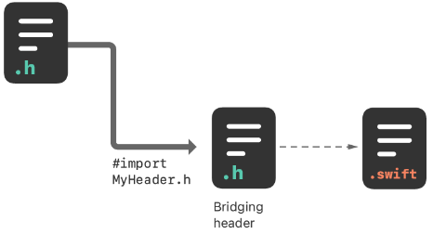
Steps to create bridge (Two ways through which bridge can be created):
- Import Code Within an App Target.
To import a set of Objective-C files into Swift code within the same app target, you rely on an Objective-C bridging header file to expose those files to Swift. Xcode offers to create this header when you add an Objective-C file to an existing Swift app.

If you accept, Xcode creates the bridging header file along with the file you were creating, and names it by using your product module name followed by "-Bridging-Header.h".
- Alternatively, you can create a bridging header yourself by choosing File > New > File > [operating system] > Source > Header File.
Edit the bridging header to expose your Objective-C code to your Swift code:
In your Objective-C bridging header, import every Objective-C header you want to expose to Swift.

Libraries Used
Name | Layer | Purpose | License type
SwiftProtoBuf | iOS | Communication | Apache 2.0
MQTT-Client | iOS | Communication | Eclipse Public
ASN1C | iOS | Communication | Evaluation
react-native-reanimated-carousel | RN | Carousel | Public
react-native-toast-message | RN | Toast | Public
react-native-vector-icons | RN | Vector Icons | Public

Main APIs/ Interfaces

Name | Language | Purpose
MqttDataBridge | Typescript | This class manage the entire Mqtt data transformation coming from the iOS native layer
AddressDataBridge | Typescript | This the data bridge to manage the address of the device. This will handle the address data coming from the Native layer
NativeEventDispatcher | Typescript | This is the main class to handle all events dispatching to the iOS native layer
NativeEventReceiver | Typescript | This is the main class which will receive the events from the Native layers
NativeEventSubscriber | Typescript | This is the main class to handle all native event subscription for the respective operating systems
IosDispatcher | Typescript | This class will handle the iOS event dispatching to the iOS native layer
IosReceiver | Typescript | This is the main class which will receive all data coming from the iOS native layer
IosSubscriber | Typescript | This class handles the subscribing of the events, and it will communicate to the iOS native bridge
AppUtils | Typescript | This is the Util class which hold all utility methods for the application which will be used in RN layer
EventManager | Swift - iOS | This class is responsible for all kind of communication with RN code.
EventDataManager | Swift - iOS | This is basically iOS layer’s public class. The above RN communication class (EventManager) basically interacts with it.
EventDataService | Swift - iOS | The is Service layer class and responsible for all kind of data flow. The above EventDataManager interacts with it internally for processing all kind of input and output data.
EventNetworkUtil | Swift - iOS | The above Service class (EventDataService) interacts with it to handle all input output requests related to only MQTT. This is responsible basically for all kind of communication with MQTT client iOS lib.
EventDataServiceComposer | Swift - iOS | EventDataService class uses it to format data which need to be send through EventNetworkUtil class. It uses Encoder classes internally which also communicate with Protobuf and ASN1 c to compose data for sending to MQTT server.
EventDataServiceParser | Swift - iOS | EventDataService class uses it to parse data which need to be send to above layer. This data comes from EventNetworkUtil. It uses Decoder classes internally which also communicate with Protobuf and ASN1 c to parse data (which comes from MQTT server) for sending to above layer.
EventLocationManager | Swift - iOS | The above Service class (EventDataService) interacts with it to handle all input output requests related to only GEOCODE. This is responsible to handle all kind of GEOCODE stuffs.

